**COUNTY GOVERNMENT OF MERU**

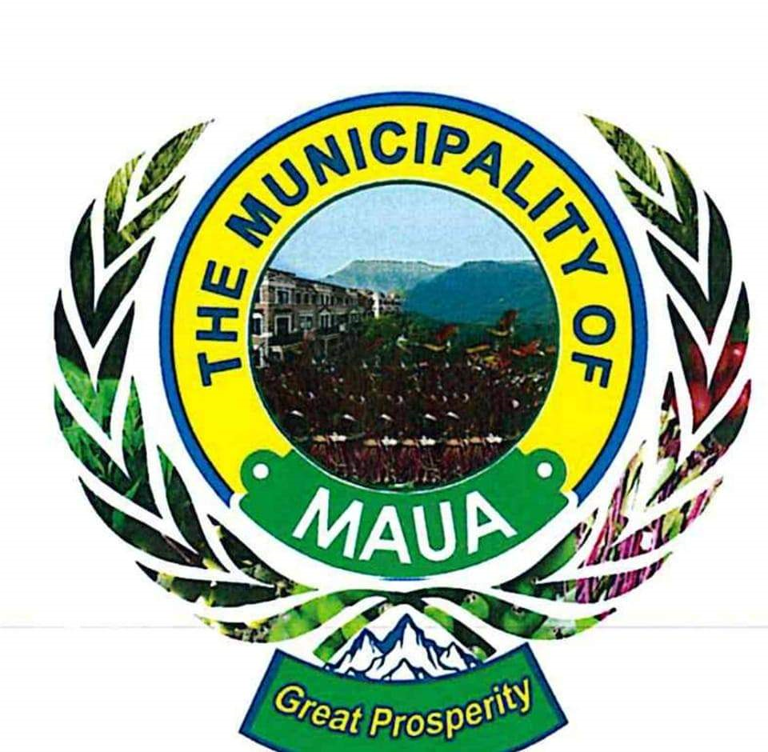

**MAUA MUNICIPALITY**

**Draft Annual Calendar for Quarterly Citizen Fora - FY 2024/2025**

**Maua Municipality**

|  |  |  |  |  |
| --- | --- | --- | --- | --- |
|  | | | | |
| **Quarter** | **Date** | **Venue** | **Main Agenda** | **Facilitators** |
| **Q1** | 15th July 2024 | Municipal Hall | Budget planning and service delivery prioritization | Municipal Manager, Finance Dept. |
| **Q2** | 15th October 2024 | Community Grounds | Review of ongoing projects and public service updates | Public Works Dept., Health Sector Representative |
| **Q3** | 15th January 2025 | Municipal Hall | Mid-year budget review and upcoming development projects | Planning and Development Dept. |
| **Q4** | 15th April 2025 | Municipal Hall | End-of-year performance evaluation and citizen feedback | Municipal Manager, Stakeholder Representatives |
|  | | | | |