**THE COUNTY GOVERNMENT OF MERU**



**MAUA MUNICIPALITY INTERGRATED DEVELOPMENT PLAN- IDeP**

# 2023/24 – 2027/28

**December, 2023**

# TABLE OF CONTENTS

TABLE OF CONTENTS ii

LIST OF TABLES iv

LIST OF FIGURES iv

GLOSSARY OF COMMONLY USED TERMS v

FOREWARD vii

ACKNOWLEDGEMENTS viii

EXECUTIVE SUMMARY ix

CHAPTER ONE: MAUA MUNICIPALITY BACKGROUND INFORMATION 1

1.0 Preamble 1

1.1 Location, size and background of Maua Municipality 1

1.3 Physical Environment 3

1.3.1 Topography 3

1.3.2 Soils Structure 3

1.3.3 Vegetation 3

1.4 Natural Resources 4

1.4.1 Forests 4

1.4.2 Minerals 4

1.4.3 Areas of Scenic Value 4

1.4.4 Energy Resources 4

1.4.5 Environment 4

1.4.6 Disaster management 5

1.5 Emerging Issues Natural Resources 7

1.5.1 Challenges 7

1.5.2 Potentials of Natural Resources 7

1.6 Population 7

1.6.1 Population size 7

1.6.3 Population structure 8

1.6.4 Culture and heritage 9

1.6.5 Migration Data 9

1.6.6 Emerging Issues. 10

CHAPTER TWO: MUNICIPAL INTEGRATED DEVELOPMENT PLAN LINKAGES WITH OTHER PLANNING AND LEGAL FRAMEWORK 12

2.0 PREAMBLE 12

2.1 LINKAGES WITH SUSTAINABLE DEVELOPMENT GOALS 12

2.2 IDEP LINKAGE WITH THE AFRICAN AGENDA 2063 12

2.3 IDEP LINKAGE WITH KENYA VISION 2030 AND THE BIG 4 AGENDA (MTP 2018-2022) 13

2.4 IDEP LINKAGE WITH THE KENYA CONSTITUTION 2010 AND OTHER LEGAL FRAMEWORKS. 13

2.5 IDEP WITH CIDP 15

CHAPTER THREE: MUNICIPALITY PRIORITIES AND STRATEGIES 16

3.0 PREAMBLE 16

3.2 VISION 16

3.3 MISSION 16

3.4 DEVELOPMENT NEEDS ASSESSMENT 16

CHAPTER 4: INSTITUTIONAL FRAMEWORK 33

4.0 Preamble 33

4.1 Mandate 33

4.2. ORGANISATION STRUCTURE 34

4.2.1 Maua Municipality Organizational Structure 34

4.2.2 Functions of Directorates 34

4.2.3: Functions of the Municipality Board 37

4.2.4: Roles and Responsibilities of Meru Municipality Key Personnel’s 37

4.3: Resource Requirement 39

4.3.1 Human Resource Requirement 39

4.3.4. Financial Resource Requirements 40

4.4: Financial Mobilization 41

4.5: Stakeholders Analysis 42

CHAPTER FIVE: MONITORING AND EVALUATION FRAMEWORK 44

5.0 Preamble 44

5.1 MONITORING AND EVALUATION APPROACH 44

5.2 MONITORING AND REPORTING MECHANISM 45

5.3 MIDTERM REVIEW AND TERMINAL EVALUATION 47

5.4 EVALUATION MATRIX 47

5.5 RISK ASSESSMENT 47

# LIST OF TABLES

Table 1: Maua Municipality Area Coverage across the Sub counties 1

Table 2: Development Needs, Priorities and Strategies 16

Table 3: Programmes and Sub-Programmes 19

Table 4: Project register 25

Table 5: Functions of Directorates 35

Table 6: Human Resource Requirement 39

Table 7: Financial Resource Requirements 40

Table 8: Financial Mobilization 41

Table 9: Stakeholders Analysis: 42

Table 10: MONITORING AND REPORTING MECHANISM 45

Table 11: Evaluation Matrix 47

Table 12: Risk Assessment 48

# LIST OF FIGURES

Figure 1: Age pyramid 9

Figure 2: Maua Municipality Organizational Structure 34

## GLOSSARY OF COMMONLY USED TERMS

**Baseline**: an analysis describing the initial state of an indicator before the start of a project/programme, against which progress can be assessed or comparisons made

**Board:** means the board of a city or municipality constituted in accordance with section 13 and 14 of the urban and cities Act

**County Executive:** consists of the county governor and the deputy county governor; and members appointed by the county governor, with the approval of the assembly, from among persons who are not members of the assembly.

**County Government**: the unit of devolved government.

**Citizen Fora:** means a forum for citizens organized for purposes of participating in the affairs of an urban area or a city under this Act.

**Development Committee:** an independent focus group centered on development and discussion of policies, guidelines, and processes by providing valuable input for development and planning.

**Development:** the process of economic and social transformation that is based on complex cultural and environmental factors and their interactions.

**Devolution:** the [statutory](https://en.wikipedia.org/wiki/Statutory) delegation of powers from the [central government](https://en.wikipedia.org/wiki/Central_government) of a [sovereign state](https://en.wikipedia.org/wiki/Sovereign_state) to govern at a [subnational](https://en.wikipedia.org/wiki/Subnational) level, such as a [regional](https://en.wikipedia.org/wiki/Regional_government) or [local](https://en.wikipedia.org/wiki/Local_government) level. Devolution in Kenya is the pillar of the Constitution and seeks to bring government closer to the people, with county governments at the centre of dispersing political power and economic resources to Kenyans at the grassroots.

**Flagship/Transformative Projects:** these are projects with high impact in terms of employment creation, increasing county competitiveness, revenue generation etc. They may be derived from the Kenya Vision 2030 (and its MTPs) or the County Transformative Agenda.

**Government:** is a means by which state policies are enforced, as well as a mechanism for determining the [policy](https://en.wikipedia.org/wiki/Policy).

**Green Economy:** the green economy is defined as an economy that aims at reducing environmental risks and ecological scarcities, and that aims for sustainable development without degrading the environment. Green economy considerations are envisaged by mainstreaming cross-cutting issues such as climate change; Environmental degradation; HIV/AIDs; Gender, Youth and Persons with Disability (PWD); Disaster Risk Management (DRM), Ending Drought Emergencies (EDE) among others.

**Human Development Index (HDI):** is a composite measure that incorporates mostly indicators derived from social sectors like life expectancy, years of schooling, and the general standard of living in the region or country.

**Indicator:** an indicator is a sign of progress /change that result from your project. It measures a change in a situation or condition and confirms progress towards achievement of a specific result. It is used to measure a project impact, outcomes, outputs and inputs that are monitored during project implementation to assess progress.

**Integration:** combining or coordinating separate county programmes and projects to provide a harmonious, interrelated plan in an organized or structured manner to form a constituent unit that function cooperatively.

**Outcome:** measures the intermediate results generated relative to the objective of the intervention. It describes the actual change in conditions/situation as a result of an intervention output(s) such as changed practices as a result of a programme or project.

**Output:** immediate result from conducting an activity i.e. goods and services produced

**Performance indicator:** a measurement that evaluates the success of an organization or of a particular activity (such as projects, programs, products and other initiatives) in which it engages.

**Programme:** A grouping of similar projects and/or services performed by a Ministry or Department to achieve a specific objective; The Programmes must be mapped to strategic objectives.

**Project:** A project is a set of coordinated activities implemented to meet specific objectives within defined time, cost and performance parameters. Projects aimed at achieving a common goal form a programme.

**Public Participation:** An action or a series of actions a person takes to involve themselves in affairs of government or community that, directly engages the public in decision-making and gives full consideration to public input in making that decision. These activities include voting, attending meetings, participating in public or private political discussion or debate on issues, signing a petition on a desired government action or policy, volunteering in community activities and contributing money to a political party or candidate of one’s choice among other similar activities.

**Spatial Development:** techniques used by planners and other actors of decision making to facilitate integrated balanced development.

**Target:** it is a planned level of an indicator achievement.

## FOREWARD

It is with great pleasure that I present the Maua Municipality Integrated Development Plan, a testament to the County Government of Meru commitment to sustainable urban development. This plan represents the inaugural five-year development blueprint for an urban area within our county, strategically addressing the challenges brought about by the recent population surge in Maua town.

In the spirit of the Kenyan Constitution of 2010, which established a devolved system of government, this plan stands as a manifestation of our collective aspirations for the highest levels of development at the local level. The constitution paved the way for the enactment of the Urban Areas and Cities Act of 2011, a crucial piece of legislation that decentralizes both political and economic power.

The birth of Maua Municipality, facilitated by the Urban Areas and Cities Act, brought to life the provisions outlined in Article 184 of the constitution. This Act provides for the classification, governance, and management of urban areas and cities, establishing criteria for their formation, and outlining principles of governance and resident participation.

This development plan is an integral component of the county's comprehensive development process, aligning with the urban development goals envisioned in the Act. The responsibility to execute this plan has been entrusted to the newly institutionalized Maua Municipality, representing a crucial step towards achieving our urban development objectives.

Drawing significant inspiration from the Meru County Integrated Development Plan 2023-27, this plan mirrors the aspirations of the people of Meru for a united, prosperous, and environmentally conscious model county. Specifically crafted to address the development needs of the municipality, it contributes synergistically to the overall growth of our county.

I am pleased to note that the formulation of this plan adhered rigorously to the principle of public participation.

This Maua Municipality Integrated Development Plan embodies our collective vision and commitment to fostering a vibrant, inclusive, and sustainable urban environment. I express my gratitude to all stakeholders whose contributions have shaped this transformative blueprint.

**Monica Kathono -CECM**

**Lands, Physical Planning, Urban Development, Housing & Public Works**

## ACKNOWLEDGEMENTS

The Maua Municipality wishes to register its appreciation to all those who were involved in the preparation of this Integrated development plan. The Team takes this opportunity to specially acknowledge the unrelenting efforts portrayed by all the technical persons who were involved in this noble process of shaping the future of our Municipality. The Office of the Governor has given immense contribution towards the preparation of this Maua Municipality IDeP

The Team is indebted to the Governor, Meru County, Hon. Kawira Mwangaza who provided great foresight in the entire plan preparation process. Special gratitude is owed to the Executive Committee Member Incharge of Urban Development CPA Monica Kathono, Chief Officer Physical Planning and Urban Development Mr Gitije Martin and Municipal Manager Mr Timothy Mwenda for excellent leadership in this preparation process. Specifically, we would like to appreciate all the resource persons more so Miriti Royford, the sector economist for excellent technical input in the process. We are specifically also grateful to the following secretariat members who consolidated, analysed and prepared the IDeP; Planner Elizabeth Mburu, Nkatha Mbaya ,Kenneth Gituma, Uniter Nyawira, Dennis Karani and CPA Linda Kendi for steering the process to completion.

Furthermore, we appreciate the partnership with National government agencies especially the Ministry of Lands and Physical Planning for their guidance in the plan preparation process and hope that our relationship will be strengthened now and in future.

The completion of this IDeP is a strong statement that the Maua Municipality has embraced the path to make Maua and in extension Meru happy.

**Timothy Mwenda**

**Municipal Manager**

**Meru Municipality**

## 

## EXECUTIVE SUMMARY

The Maua Municipality Integrated Development Plan (IDeP) is a comprehensive five-year blueprint designed to guide the development initiatives within the Municipality Area. Established under the provisions of the Urban Areas and Cities Act no. 13 of 2011, the IDeP aligns with the constitutional requirements for integrated development planning, ensuring that every city and town operates within a strategic framework.

IDeP outlines the socio-economic and infrastructural baseline situation of Maua Municipality as of 2023. This includes population demographics, physiographic and natural conditions, locational description, size, administrative, and political units.

Chapter 2 delves into the application and linkages of international commitments such as Sustainable Development Goals and African Agenda 2063. Legal documents, including Kenyan Vision 2030, Kenya Constitution 2010, County Government Act, and County Integrated Development Plan, are detailed to emphasize alignment with broader national and international development agendas.

Rigorous public participation processes were undertaken to identify programs and projects embedded in the IDeP. This ensures community involvement and adherence to constitutional requirements.

Chapter 4 outlines the institutional framework to implement the IDeP. The Municipality, established as a Semi-Autonomous Government Agency, is presented with a focus on both the institutional arrangement and the resource requirements. Financial needs for the five-year period are estimated at Ksh 2584 Million

Chapter 5 describes the Monitoring and Evaluation mechanism, emphasizing the municipality's commitment to improving the effectiveness and quality of program tracking. The section elucidates how the institution will measure performance and track the progress of IDeP implementation.

The Maua Municipality Integrated Development Plan aims to drive sustainable development, aligning with national and international goals. By prioritizing community participation, legal compliance, and effective institutional frameworks, IDeP charts a path for transformative growth over the next five years.

# CHAPTER ONE: MAUA MUNICIPALITY BACKGROUND INFORMATION

## 1.0 Preamble

This chapter introduces the baseline situation for the Maua municipality. It encompasses the population demographics, physiographic and natural conditions as well as locational description, size, administrative and political units. It is basically an overview of the start off point in terms of socio-economic and infrastructural situation as at the baseline year of 2023.

## 1.1 Location, size and background of Maua Municipality

Maua Municipality is located within Igembe south Sub County and it also covers some parts of Igembe central sub-county. The Igembe south sub-county is located on the South Eastern part of Meru County. It borders Kitui and Tharaka Nithi counties to the South, Igembe Central to the East and Tigania East to the West. The Municipality covers five wards including; Maua ward, Parts of Igembe East, Kiegoi/Antubochiu, Kanuni and Njia wards. Maua Town is the second largest town in the Meru County after Meru town. Maua is a located in Meru County 60 km North of Meru town. It is popular for production of Miraa which supports most of the people and subsidiary businesses in the area. The town has an altitude of 5,429 feet (1654m) above the sea level above the sea level with geographical coordinates of 0° 14' 0" North, 37° 56' 0" 37o 39’East. It serves as one of the major routes to Meru National park and is surrounded by a number of expansive tea and Miraa farms. Its proximity to Meru National park and Nyambene hills has also contributed to its popularity since the Nyambene hills and Meru National Park increase its tourism potential. The Municipality is located area within Igembe south Sub County and it also includes some parts of Igembe central sub-county covering an area of 37.5 sq. Km. This consists of the entire area of Maua Township and its environs, as well as Kimongoro, Maili Tatu, Kithetu, and Kiegoi markets, which are set as action plans as shown in the map below.

Table 1: Maua Municipality Area Coverage across the Sub counties

|  |  |
| --- | --- |
| SUB-COUNTY | AREA IN KM2 |
| Igembe South | 838.5 |
| Igembe Central | 801.6 |

Map 1: Environmentally fragile areas

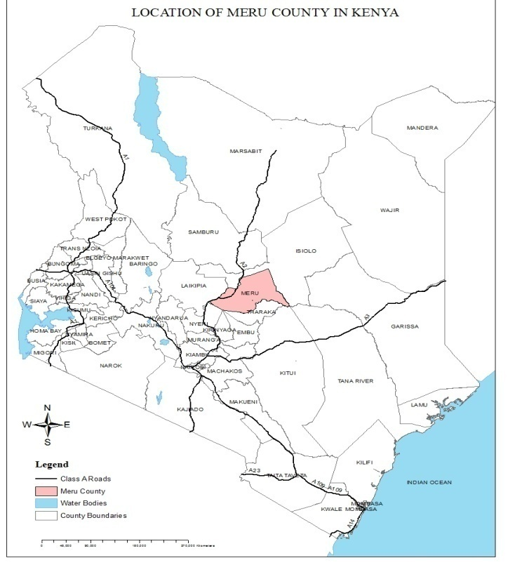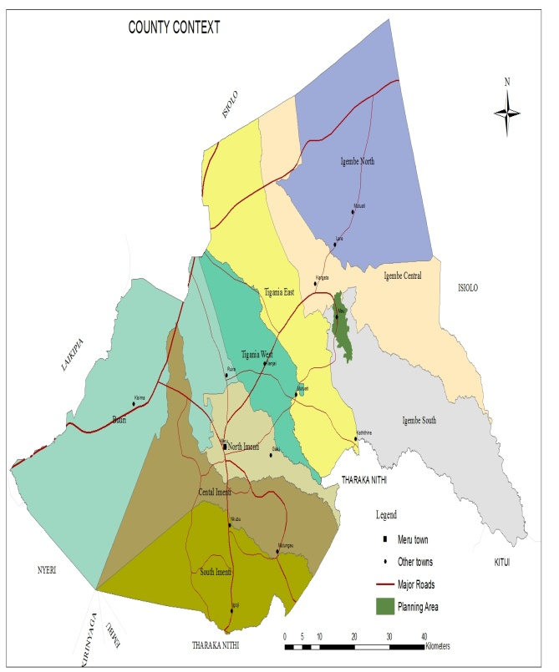

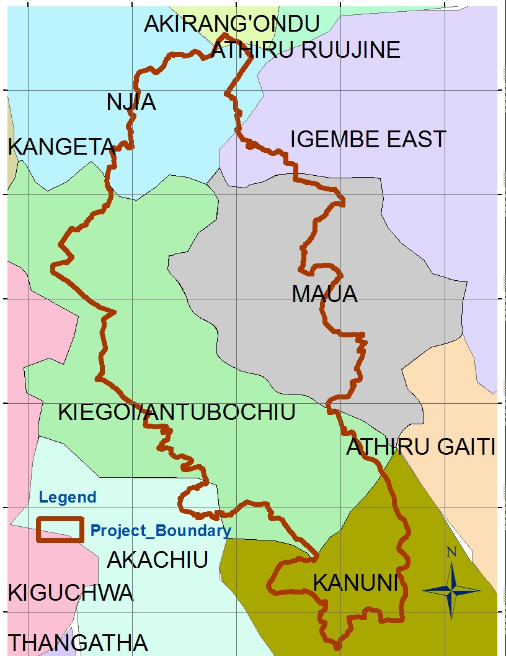

## 1.3 Physical Environment

### 1.3.1 Topography

The topography of the municipality is generally hilly with Maua town (1640 m) lying as a strip at the bottom of the hills and gentle sloping towards the southern part. Kiegoi market lies at altitude of 1920m, Maili Tatu 1710m and Kimongoro lies 1300m above the sea level.

The general landscape slopes south eastwards as this is the direction the rivers flow. However the area has hills and valleys punctuating the landscape. The undulating landscape affects the climate and vegetation of the area.

The topography has affected the growth of the Maua Township. The terrain also affects the provision of infrastructure and services. The terrain also limits areas available for development.

### 1.3.2 Soils Structure

The municipality is underlain by Precambrian basement rock system and mostly by volcanic and sediments from the eruption of Nyambene hills and associated parasitic cones. The soils of Maua town, Kiegoi and Maili Tatu are deep volcanic red soils. These soils are well drained and fairly fertile. The soils of the volcanic plateau are moderately deep to shallow with various textures.

### 1.3.3 Vegetation

The municipality has both exotic and natural vegetation. The natural vegetation is mostly found on the forest near Kiegoi market. Some of the common indigenous trees in the area include the Meru Oak, Cordia, Camphor and Cedar. Some parts of the area also have exotic tree species. The types of trees vary with eucalyptus being the most common in the inhabited areas. Cash crops and food crops grown in the area also forms part of the vegetation. The main crops being bananas, coffee, tea, Miraa, maize, fodder crops and other food crops.

## 1.4 Natural Resources

### 1.4.1 Forests

There are no gazeted forests in the planning area. However, a small portion of Nyambene forest lies adjacent to Kiegoi market.

### 

### 1.4.2 Minerals

The planning area and the entire Igembe South sub-county are not known to have any mineral deposits of precious stone, ores or mineral oils. There is, however the mining of building materials such as building stones within and in other places near the municipality.

### 1.4.3 Areas of Scenic Value

The landscape of the municipality is attractive. It has river, valleys, vegetation, swamps and hills such Nyambene all of which combine to create an interesting landscape. Also, some rivers have waterfalls which are a great sight to behold for any nature lover.

### 1.4.4 Energy Resources

The energy sources commonly used include firewood, charcoal and kerosene in the rural areas. Firewood is majorly obtained from the both natural and planted forest.

### 1.4.5 Environment

Maua and its environs have a favorable environment for human settlement. It is characterized by gentle and rough topography that gives way to flatter terrain in some areas. The overall slope of the land is towards the south; consequently, drainage is in that direction. The main river in the municipality area is river Ura which has its tributaries flowing from Nyambene ranges, and proceeds southwards through Meru National Park. Maua town and its environs face major environmental challenges such as poor solid and liquid waste management, loss of biodiversity, water pollution, land degradation, soil erosion, and poor quarrying practices.

The high demand for construction materials and fuel wood has led to high rate of deforestation. The quarrying for both building stones and sand in unsustainable way and without any rehabilitation plan for the sites is impacting negatively to the environment. Pollution from urban centers to nearby rivers is also a major challenge.

Environmentally fragile areas in the municipality area include rivers and the marshland around them, swampy areas, the forest and steep hills. The rivers are threatened by pollution and encroachment. Due to poor farming methods, a lot of silt is washed up to the rivers. This has led to many of them becoming shallow, hence holding less water. As this occurs, the rivers become smaller and may eventually disappear. Mporoko swamp is also a feature in this category and it is currently threatened by human activities such as settlement and cultivation. The Maua basin is one area in the town that is environmentally fragile and poses environmental risks.

### 

### 1.4.6 Disaster management

There are various types of disasters that occur in Maua and its environs; these are road accidents, flooding, accidental fires and arson. The county response to disasters was considered inadequate by the respondents due to the time they take to reach the point of occurrence. Preparedness for disaster is low in the area; therefore all efforts should be made to make the county more responsive. Challenges that affect disaster responsiveness include lack of supervision of building construction, poor lighting, and lack of fire extinguishers in buildings and poor accessibility in some areas.

Map 2 : Environmentally fragile areas

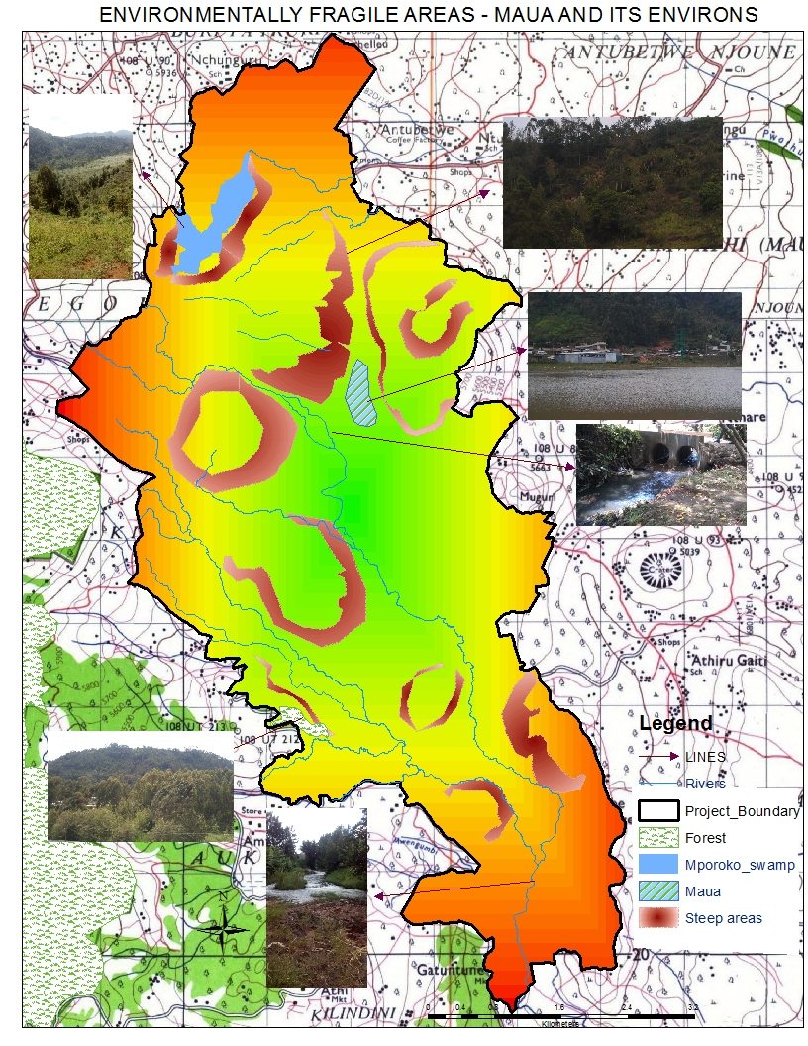Source: Geoland surveys 2016

## 1.5 Emerging Issues Natural Resources

### 1.5.1 Challenges

* Encroachment into environmentally fragile areas is threatening the biodiversity and sustainability of Maua town and its environs.
* The County government and NEMA have been reluctant in enforcing environmental laws, thus leading to environmental degradation. The county and NEMA should work hand-in-hand to ensure better environmental management if a sustainable town is to be achieved.
* Minimal material recovery and recycling of waste products
* Air and water pollution
* Inadequate drainage channels in Maua town
* Inadequate consideration and awareness on the environment
* Decreasing stocks of natural resources
* Land use conflicts
* Lack of proper enforcement of the environmental act
* Degradation of catchment areas
* Lack of interest to activities of common good
* Accumulation of solid waste

### 1.5.2 Potentials of Natural Resources

* The local residents need to be more vigilant in reporting and better managing their environment.
* Presence of natural resources i.e. building materials, vegetation
* Serene environment for investment in hotels and conference facilities
* Availability of water
* Existing policies and laws i.e. EMCA
* Appropriate weather for a range of activities
* The hilly topography are favorable for hill climbing, cable cars, zip lines and surveillance

## 

## 1.6 Population

### 

### 1.6.1 Population size

The planning area covers Igembe South Sub-county and also some parts of Igembe Central Sub-county. The County population as per the 2019 Kenya Population and Housing Census (KPHC) is 1,545,714consisting of 767,698males, 777,975females and 41 intersexes. According to KNBS KPHC 2019, 22,121 of the population are within Maua Township while 29,780 are within the rest of the municipality area. The growth in population will strain the available resources such as land. This calls for prior planning of available resources and expansion of social and economic facilities to accommodate the expanding population.

There is higher density in Igembe south as compared to Igembe central which may be attributed to high fertile land in Igembe south, which is good for farming whereas in Igembe central there are some areas which are sparsely populated.

### 1.6.3 Population structure

From the population pyramid below, the age group of 0-4 years is more than any other age group. This shows that there is an improvement in child survival that has resulted in a youthful population. The pyramid is decreasing as more people are getting older-steady upwards narrowing shows that more people die at each higher age band. This pyramid indicates that there is a high birth rate, a high death rate and a short life expectancy. Also the structure shows that there is a lot of pressure exerted to the working population because when comparing the ratio of the working population to the sum of the aged population (65+) and the population of 0-14 years will be less. Below is the population pyramid for Maua and its environs also showing the distribution of population at different age brackets.

Figure 1: Age pyramid

Source: KNBS 2019

### 1.6.4 Culture and heritage

Maua is a home for Ameru people. Currently it is regarded as a cosmopolitan region because people from different backgrounds and locations have come and settled there. There was deep reverence for the spirit of the living dead. Ameru believed in offering sacrifices to their dead ancestors. The divine leader of the Ameru was called the Mugwe. These were respected persons who made sacrifices and performed healing on behalf of the tribe. However, with the arrival of Christianity, the cultural rites and functions have become obsolete.

### 1.6.5 Migration Data

On migration is based on the last population and housing census in 2019. However, general trends on migration can be observed. Daily migration is evident from the fact that the day population in Maua town is approximately double the night time population. This means that some of the people who work or run businesses within the town may well live outside Maua Township.

Also Maua experiences seasonal migration. Considering the institutions of higher learning based in Maua, it is expected that many students and staff are in Maua during the semesters/terms and go back home when the institutions close. The same case could apply to boarding schools within the planning area. Such institutions include Maua Girls High School, Igembe Boys High School, Fr. Solidat among others.

Long-term migration is also brought about by Maua town’s position as an administrative center and a commercial hub has attracted many immigrants. Some come to Maua to work as civil servants, employees of major commercial institutions and others for business. These immigrants may stay in Maua for a couple of years and others continue to live in Maua permanently. This has contributed to the cosmopolitan nature of the town.

The other type of migration experienced is rural-urban migration seeing that secondary towns now absorb most of the rural-urban migrants. Perhaps also urban-urban migration as people move to or from other towns. The statistics that define these patterns are however not available.

### 1.6.6 Emerging Issues.

#### 1.6.6.1 Challenges

The population of the planning area is largely youthful with more than half being under 15 years of age. The challenge is to provide quality education, health care and meaningful employment opportunities.

The consistent increase in population continues to exert pressure on the existing infrastructure and services. This has created a deficit in the provision of some services such as water and sanitation, solid waste management, health and education.

The large population has also led to an increase in the built-up area, thus extending urban development beyond the municipal boundary into the agricultural hinterland and into environmentally fragile lands (adverse environmental effects). This affects food security and agricultural production which is the main economic activity of the planning area

The increase in population has also led to the increased subdivision of agricultural land. Some previously agricultural areas have since become residential.

Competition for spaces to carry out economic activities and businesses such as jua kali sheds open air market among others. This has led to such activities taking place in road reserves.

#### 1.6.6.2 Opportunities

* The increasing population increases markets for goods and services in the planning area.
* The largely youthful population provides affordable labour to existing and potential investors in the area.
* The different cultures of the population offer an opportunity for cultural mix and exchange.
* The population offers an opportunity for governments, researchers, environmental, economic, social and physical planners to plan for it.
* The position of Maua as an administrative town and commercial hub serving the surrounding areas and other far and large areas such as Part of Garissa, Wajir, Isiolo, Tharaka Nithi and Meru has seen it attract a large number of immigrants.
* A high population engaging in business activities increases the revenue base for governments.
* A high population creates economies of scale in provision of infrastructure and services as well as market for production companies.

# CHAPTER TWO: MUNICIPAL INTEGRATED DEVELOPMENT PLAN LINKAGES WITH OTHER PLANNING AND LEGAL FRAMEWORK

## 2.0 PREAMBLE

This chapter provides and details the application and linkages of various international commitments, like Sustainable Development Goals and African Agenda 2063, Legal documents which includes; Kenyan Vision 2030, Kenya Constitution 2010, County Government Act and County Integrated Development Plan to the Maua Municipality Integrated Development Plan.

## 2.1 LINKAGES WITH SUSTAINABLE DEVELOPMENT GOALS

SDGs are global aspirations to transform the world into a better place by 2030. They provide a shared blueprint for peace and prosperity for people and the planet, now and into the future. This IDeP has taken cognizance of SDGs and both projects and programs proposed are mainstreamed to the 17 SDGs. This Municipality IDeP is formulated to address SDG 6, 9, 11, 15 and 17.

Goal 6 ensures availability and sustainable Management of water and sanitation for all; this is addressed through projects that are aimed at providing clean water and proper drainage within the municipality.

Goal 9 which is responsible for resilient infrastructure, promote inclusive and sustainable industrialization and foster innovation, has been factored in the preparation of this IDeP where the Municipality has prioritized the development of standard roads infrastructure that will ensure an elaborate road network that sets stage for industrialization.

Goal 11 Make Cities and human settlement inclusive, safe, resilient and sustainable. This IDeP basically looks at developing a municipality that guarantees resilience, sustainability and safety for work, residence and investments.

The protection of the urban environment is a key priority for the Municipality. As part of its role to manage Solid & Liquid waste as well as protect fragile eco systems within the Municipality this plan is consistent to address Goal 15. The plan sets out specific initiatives towards achieving the goals which include the rehabilitation of the rivers, water sources and the conservation and maintenance of recreation of park(s).

A number of projects will be achieved through partnership with national and international bodies hence fostering partnership which is part of goal 17: Strengthen the means of implementation and revitalize the global partnership for sustainable development.

## 2.2 IDEP LINKAGE WITH THE AFRICAN AGENDA 2063

Agenda 2063 is an African Agenda that seeks to deliver on a set of Seven Aspirations each with its own set of goals which if achieved will move Africa closer to achieving its vision for the year 2063. It reflects our desire for shared prosperity and well-being, for unity and integration, for a continent of free citizens and expanded horizons, where the full potential of women and youth are realized, and with freedom from fear, disease and want. This IDEP has been aligned with the Aspiration 3 and 6 of the Africa Agenda 2063.

The Municipality is subject of building a self-sustainable institution that with structured leadership geared to develop and transform as per goal 2 of Aspiration 3 of a capable institutions and transformed leadership in place at all levels.

The municipality projects and programs are framed through public and citizen participation thus aligning with developments which are people-driven, relying on the potential of African people, especially its women and youth, and caring for children.

## 2.3 IDEP LINKAGE WITH KENYA VISION 2030 AND THE BIG 4 AGENDA (MTP 2018-2022)

Kenya Vision 2030 refers to the long-term development strategy for Kenya; it aims to transform Kenya in to a modern, globally competitive, middle income country providing high quality life to its entire citizen.

To realize vision 2030, it is phased to be implemented in successive five-year Medium-Term Plans. The country currently is implementing MTP 2018-2022 referred to as the Big 4 Agenda. The Big Four Agenda items are: Food security, manufacturing (mainly focusing on job creation in this area), affordable universal health care and affordable housing.

The IDeP is developed and anchored as part of enablers that will enable the country to achieve both vison 2030 and Big 4 Agenda.

## 2.4 IDEP LINKAGE WITH THE KENYA CONSTITUTION 2010 AND OTHER LEGAL FRAMEWORKS.

This IDeP has been prepared in consistence with Kenya Constitution 2010. According to the Fourth Schedule it outlines the functions of the national and county governments. A total of 14 functions have been devolved to the counties. The main ones include: county planning and development; Agriculture; county health services; control of air pollution, noise pollution, other public nuisances and outdoor advertising; cultural activities, public entertainment and public amenities; county roads and transport; animal control and welfare; trade development and regulation; pre-primary education and village polytechnics; specific national government policies on natural resources and environmental conservation; county public works and services; firefighting services and disaster management; and, control of drugs and pornography. Emphasis has also been made for the counties to ensure participatory development and capacities are developed at the county and community level.

Five laws which provide the framework for devolution have been enacted, namely: Urban Areas and Cities Act, 2011; The County Governments Act, 2012; The Transition to Devolved Government Act, 2012; The Intergovernmental Relations Act, 2012 and The Publi­­­­­­­­­­c Finance Management Act, 2012.

Other laws that are put into consideration when drafting this IDeP to arrive to a functional municipality include the following; the Physical Planning Act Cap 286, which was enacted in 1996 and regulates all physical planning activities in Kenya. The Act give guidance on the objectives and the contents of structure plans, development plans, advisory plans, zoning plans, subdivision plans stipulating the planning preparation and approval processes which has been adopted in the projects.

The Land Acts no 6 of 2012 which provides for the conversion of land from one category to another for the various listed purposes which include land use planning.

Thirdly, the Environment Management and Coordination Act (EMCA) of 1999 which opens a way for substantial public involvement in any major development decisions, which have environmental bearing. The Land use change, shall only be undertaken after Environmental Impact Assessment by an independent body.

The Water Act of 2002 provides for management, conservation, use and control of water resources and for the acquisition and regulation of rights to use water. Further, it provides for the regulation and management of water supply and sewerage services.

The Public Health Act cap 242, the act that makes provision for securing and maintaining the health of public. It sets standards to be observed by people who wish to carry out trade in food stuff and the conditions under which trading should be done.

The Land Control ACT Cap 302, where Meru Municipality is located in an agricultural area thus falls within the land control area. The land control board holds significant mandate in matters related to land use, subdivisions, and disposal of agricultural land.

Finally, the Urban Areas and Cities Act no 13 of 2011. Under this act, every city and town is expected to operate within the framework of integrated development planning. The plan will be the basis for service and infrastructure provision.

This Municipal Integrated Development Plan is the first to be formulated by the municipal board to actualize the provisions of the Urban Areas and Cities Act, 2011, Provisions of the 2010 Constitution as well as Public Finance Management Act, 2012. It seeks to provide the basis which will guide the execution of the priority projects and programs within the Municipality.

## 2.5 IDEP WITH CIDP

A County Integrated Development Plan is a super plan for the counties that gives an overall framework for development. It aims to co-ordinate the work of both levels of the government in a coherent plan to improve the quality of life for all the people and contribute towards devolution. The county governments Act section 108 outlines the county integrated development plan (CIDP) this outlines the county development goals covering a period of five years.

Kenya’s Public Finance Management Act provides that no public funds shall be appropriated outside a county’s planning framework. The CIDP contains information on development priorities that inform the annual budget process, particularly the preparation of annual development plans, the annual county fiscal strategy papers, and the annual budget estimates.

The Maua Municipal IDeP has been drafted and prepared in reference with the Meru CIDP 2023-2027.

# CHAPTER THREE: MUNICIPALITY PRIORITIES AND STRATEGIES

## 3.0 PREAMBLE

This chapter focuses on the development strategies of the Municipality in the light of the current overview in relation to developmental needs. It gives an overview of the sectors, their status in resource utilization and the presenting opportunities for optimization of resources. The chapter highlights the development priorities by sector; The Sector vision, mission, sector values and objectives for each have also been captured.

Sector development needs and areas of prioritization and strategies have clearly been highlighted. It details the future programs and projects to be implemented in the first generation IDeP 2024-2028.

Lastly, the chapter makes an overview of the key proposed flagship/transformative whose implementation will have high impact in terms of creation of employment, increment of county competitiveness, revenue generation and cross-county engagements and will go a long way in realizing the dream of ‘Making Meru Happy’.

## 3.2 VISION

To be a trend-setting, dynamic Municipality delivering quality services

## 3.3 MISSION

To render affordable quality services, promote prosperity and facilitate social-economic Development through application of transparent corporate governance, integrated development planning, skills development and the sustainable use of resources

## 3.4 DEVELOPMENT NEEDS ASSESSMENT

Table 2: Development Needs, Priorities and Strategies

|  |  |  |  |
| --- | --- | --- | --- |
| A | Need | Priorities | -Strategies |
| A | Urban development management | Establishment and operationalization of urban governance structures  -Development, upgrading and maintenance of urban infrastructure | -Implementation of Maua integrated urban spatial plan.  -Develop recreation facilities in all our MUNICIPALITY  -Implement Beautification program (eco-friendly)  -Completion of the Construction of; water & sewerage system.  -Installation and maintenance of street lights, flood lights & transformers. |
| B | Adequate public land /land Banking | -municipal wide public land inventory | -Identify, map and preserve existing public lands.  -Repossess grabbed public land within the municipality.  -Purchase land for public use and future investment within the municipality. |
| C | Environment management & Conservation | -Development and operationalization of Meru Municipality Integrated Waste Management Policy.  -Develop and implement an Environmental conservation and protection strategy | -Purchase of land for the purposes of a convenient dumpsite.  -Purchase of specialized garbage Trucks, Personal protective equipment’s, Back hoe, Litter bins  -Construction of Receptacles & Commercial waste Incinerator  -Maintenance of Murera dumpsite.  -Operationalization and Maintenance of sewerage System  -Create awareness of good waste management practices (The three Rs: Reduce, Reuse & Recycle)  - Landscaping of highways, parks, streets  -Afforestation  -adoption of renewable energy |
| D | Town transport system | -Establish and operationalize of transport management strategy | - Installation of CCTVs, Traffic Surveillance Systems, Road safety signage  -Designing of the municipality roads to ease traffic flow.  -Naming of the town streets. |
| E | Enforcement Capacity Development | -Establish and operationalize the municipality enforcement and inspectorate unit  -Develop and Implement the Maua County Enforcement Service Act | -Recruit, train and deploy enforcement officers  -Build enforcement lines/camps in Maua  -Procure vehicles and equipment for enforcement service  -Establishment of a municipality court.  -Public awareness of the county laws. |
| F | Trade Development | - Implementation of existing of Trade policy(s)  -Support of SMEs (who include women, youth and people with disability)  -Promote a 24 Hr Economy | -Construction of market boundary walls, market stalls/kiosks, sheds, floodlights, modern market toilets |
| G | Tourism Development & Marketing | -Tourist Site Mapping and development  -Marketing of new and existing tourist sites | -Develop infrastructure for sites.  -Promotion of Agro-tourism, medi-tourism and Conference tourism.  -Media awareness campaign for the promotion of Meru National Park. |
| F | Public Health Promotion | - Health education/awareness on preventive and promotive health care  -Implementation of the public health Act | - Recruit, train and deploy public health officers  -Media awareness campaigns  -Integration of sign language in our health promotion and awareness campaigns.  -Public barazas, church and school sensitization sessions |
| H | Health services | -Provision of health infrastructure, equipment, personnel, drugs etc. | Construction and equipping of health centers and dispensaries;  Hiring of medical personnel |
| I | Disaster Management | Develop and implement a disaster management strategy | -Establish of a call center;  -Purchase of firefighting equipment; ambulances  - Recruit, train and deploy fire fighters  -Implementation of OSHA |
| J | Improving informal settlement | Improve standards of living in informal settlements  Establishment and operationalization of Material recovery center | * Paving of roads * Improving sanitation * Provision of clean water * Erection of floodlights and street lighting * Construction of a material recovery centre * Implementation of the waste management policy |

3.5 p

Table 3: Programmes and Sub-Programmes

|  |  |  |  |  |  |  |  |  |  |
| --- | --- | --- | --- | --- | --- | --- | --- | --- | --- |
| Programme 1: Urban Institutional Development | | | | | | | | | |
| **Objective (s):**   1. **To improve governance within the municipality** 2. **To create and sustain and attractive safe secure and well managed municipality** 3. **To enhance service delivery excellence** | | | | | | | | | |
| **Outcome (s):**   1. **Enhanced public order; Enhanced local govern systems & Improved transparency and accountability in citizen engagement in decision making of urban government** | | | | | | | | | |
| **Sub-programme** | **Key Output** | **Baseline** | **Key performance indicators** | **Planned Targets** | | | | |  |
| **2023/24** | **2014/25** | **2025/26** | **2027/28** | **2028/29** | **Total Budget (Ksh.) in Millions** |
| **Sp 1.1 Municipality Governance Structure** | Operational Board | - | Number of Board meetings held annually | 4 | 4 | 4 | 4 | 4 | **2.5** |
| Operational Municipal administration | 1 | Number of offices established and equipped per year | 3 | 15 | 5 | 5 | 5 | **16** |
| Established Municipal court | - | Number of Courts per year | 0 | 0 | 0 | 1 | 0 | **10** |
| **Sp 1.2**  **Capacity Building** | Board Training | - | Number of trainings per year | 5 | 4 | 4 | 4 | 4 | **5** |
| Staff Training | - | Number of staff trained | 30 | 60 | 90 | 120 | 150 | **25** |
| **Sp 1.3**  **Public Participation** | Citizen for a | 2 | Number of fora held per year | 15 | 10 | 10 | 10 | 10 | **25** |
|  |  |  |  | **Programme 1 Total(Ksh) In Millions** | | | | | **83.5** |
| **Programme 2: Urban Infrastructure Development** | | | | | | | | | |
| **Objectives**  **1. to improve health, wellbeing and quality of life**  **2. To enhance sustainable natural resources management in the municipality**  **3.To enhance social infrastructure needs** | | | | | | | | | |
| **Outcome**  **1. Improved health of municipality dwellers and user.**  **2.Enhanced economy** | | | | | | | | | |
| **Sub-programme** | **Key Output** | **Baseline** | **Key performance indicators** | **Planned Targets** | | | | |  |
| **2023/24** | **2014/25** | **2025/26** | **2026/27** | **2027/28** | **Total Budget (Ksh.) in Millions** |
| **Sp 2.1**  **Roads and Transport infrastructure** | Paved Parking lots | 500 | Number of Parking lots paved annually | 300 | 200 | 200 | 200 | 100 | **200** |
| Paved roads | 0.5 | Number of KMs Paved annually | 2 | 2 | 2 | 2 | 2 | **500** |
| Paved Walk-ways & Cycling Lanes |  | Number of KMs Paved annually | 3 | 3 | 3 | 3 | 3 | **80** |
| Street Lights | 50 | Number of street lights installed | 20 | 20 | 20 | 20 | 20 | **15** |
| CCTV | **-** | Number of Street Cameras Installed | 0 | 0 | 30 | 50 | 50 | **100** |
| Traffic Lights | **-** | Number of traffic lights Installed per year | 0 | 0 | 4 | 4 | 4 | **50** |
| **Sp 2.2**  **Water and Sewerage Infrastructure** | Completion Sewer line | **-** | Number of KMs constructed Per Year | 0 | 1 | 2 | 2 | 5 | **200** |
| Installation of extension water Pipeline | **-** | Number of KMs constructed Per Year | 1 | 2 | 4 | 4 | 8 | **100** |
| **Sp 2.3**  **Improving informal settlement** |  |  |  |  |  |  |  |  |  |
| Constructed sanitation blocks | **-** | Number of sanitation blocks | - | 2 | 2 | 2 | 2 | **120** |
| Floodlights installed | **5** | Number of floodlights | 0 | 2 | 2 | 2 | 2 | **16** |
| Street lights installed |  | Number of streetlights | 0 | 5 | 5 | 5 | 5 | **10** |
| Established and operational material recovery centre | **-** | Number of centres | 0 | 0 | 1 | 1 | 1 | **180** |
|  |  |  |  | **Total Budget (Ksh.) in Millions** | | | | | **1571** |
| **Program 3: Environmental Management** | | | | | | | | | |
| **Objectives**   1. **To identify and enhance new technology for sustainable development** 2. **To support pollution prevention** 3. **Promote sustainable development that promotes environmental protection and management** | | | | | | | | | |
| **Outcomes**   1. **Improved health** 2. **Enhanced cleanliness** 3. **Improved recycling and reuse practices at point of waste generation** | | | | | | | | | |
| **Sub-programme** | **Key Output** | **Baseline** | **Key performance indicators** | **Planned Targets** | | | | | |
| **2023/24** | **2014/25** | **2025/26** | **2026/27** | **2027/28** | **Total Budget (Ksh.) in Millions** |
| **Sp 3.1**  **Solid waste management**  **Environmental conservation** | Specialized Garbage trucks | **2** | Number of specialized garbage trucks | 1 | 1 | 1 | 1 | 1 | **60** |
| Garbage receptacles | - | Number of garbage receptacle constructed annually | 2 | 2 | 2 | 2 | 2 | **5** |
| Constructed incinerator | **-** | Number of incinerators constructed | 0 | 0 | 1 | 0 | 0 | **30** |
| Reclaimed of rivers | **-** | Number of rivers reclaimed in the municipality annually | 1 | 1 | 1 | 1 | 1 | **25** |
| Afforestation | **-** | Number of trees planted | 6000 | 4000 | 4000 | 2000 | 2000 | **4.5** |
| Landscaped streets | **-** | Number of streets landscaped | 2 | 2 | 2 | 2 | 2 | **20** |
| Material recovery center | **-** | Number of material recovery centers established per year | 0 | 1 | 1 | 1 | 1 | **32** |
| **Total** | | | | | | | | | **176.5** |
| **Programe 4: Trade and Enterprise Development** | | | | | | | | | |
| **Objectives**   1. **To enhance equitable development and increase employment** 2. **To enhance technology and innovation** 3. **Promote sustainable industrial development for effective resource utilization** 4. **Open up avenues of value addition taking cognizance of regional and global markets for primary product** | | | | | | | | | |
| **Outcome**   1. **Incubation of small businesses** 2. **Increased number of tourists to the Municipality** 3. **Improved standards of living** | | | | | | | | | |
| **Sub-programme** | **Key Output** | **Baseline** | **Key performance indicators** | **Planned Targets** | | | | |  |
| **2023/24** | **2014/25** | **2025/26** | **2026/27** | **2027/28** | **Total Budget (Ksh.) in Millions** |
| **Sp 4.1**  **Improvement of markets** | Constructed modern market | **-** | Number of modern market constructed | **2** | **2** | **2** | **2** | **2** | **300** |
|  |  |  |  |  |  |  |  |  |
| **Sp 4.2**  **Enterprise development** | Capacity building of SMEs | **-** | Number of SMEs trained in business best practices | **--** | **100** | **100** | **100** | **100** | **10** |
| **Sp 4.3**  **Tourism Development & Marketing** | Mapped tourism site | **-** | Number of tourism guides developed | **-** | **0** | **1** | **0** | **0** | **10** |
| Developed tourist attraction sites | **-** | Number of tourist sites developed | **-** | **0** | **2** | **5** | **8** | **45** |
| **Total** | | | | | | | | | **365** |
| **Programme 5: Disaster management** | | | | | | | | | |
| **Objectives;**   1. **To improve disaster preparedness** 2. **To safeguard and make available vital materials supplies and equipment to ensure the safety and reliable recovery of records for predictable disasters** | | | | | | | | | |
| **Outcomes;**   1. **Enhanced efficiencies in emergency response** | | | | | | | | | |
| **Sub-programme** | **Key Output** | **Baseline** | **Key performance indicators** | **Planned Targets** | | | | |  |
| **2023/24** | **2014/25** | **2025/26** | **2026/27** | **2027/28** | **Total Budget (Ksh.) in Millions** |
| **Sp 5.1**  **Disaster Response Investments** | Emergency Fund | **-** | Amount of Fund Per Year (Ksh. In Millions) | **20** | **20** | **20** | **20** | **20** | **100** |
| Established, operational call and data center | **-** | Number of call and data center established | **0** | **0** | **0** | **1** | **0** | **50** |
| Fire engine purchased | **-** | Number of fire engines purchased | **0** | **0** | **1** | **1** | **0** | **24** |
| Purchased ambulances | **-** | Number of ambulances purchased | **0** | **0** | **1** | **1** | **1** | **21** |
| Modern fire station | **-** | Number of modern fire stations built | **0** | **0** | **0** | **1** | **1** | **20** |
|  |  |  |  | **Programme: Total Budget (Ksh.) in Millions** | | | | | **215** |
| **Grand Total (Ksh.) in Millions** | | | | | | | | | **2411** |

Table 4: Project register

| **Sub Programme** | **Project name; Location (Ward/Sub county/)** | **Estimated cost (Ksh.) (Million)** | **Source of funds** | **Time frame** | **Performance indicators** | **Implementing Agency** | **Other stakehold** |
| --- | --- | --- | --- | --- | --- | --- | --- |
| Sp 1.1 Municipality Governance Structure | Construction of offices, refurbishment and equipping of Municipality offices | 20 | CGM & Development Partners | 2023 -2028 | Number of offices constructed and refurbished | CGM/  Maua Municipality | Residents, Development partners |
| Citizen fora | 2 | CGM & Development Partners | 2023 -2028 | Number of citizen fora | CGM/  Maua Municipality | Residents, Development partners |
| Renovation and expansion of Municipal hall | 10 | CGM & Development Partners | 2023 -2028 | % Completion | CGM/  Maua Municipality | Residents, Development partners |
| Purchase of Municipality van | 5 | CGM & Development Partners | 2023 -2028 | Number of Municipality van purchased | CGM/  Maua Municipality | Residents, Development partners |
| Benchmarking and capacity building on staff | 5 | CGM & Development Partners | 2023 -2028 | Number of Capacity building meetings | CGM/  Maua Municipality | Residents, Development partners |
| Capacity building of Municipal board | 5 | CGM & Development Partners | 2023 -2028 | Number of capacity building events | CGM/  Maua Municipality | Residents, Development partners |
| **Programme 2: Urban Infrastructure Development** | | | | | | | |
| Sp 2.1  Roads and Transport infrastructure | Paved Parking lots | 200 | CGM & Development Partners | 2023 -2028 | Number of Parking lots paved annually | CGM/  Maua Municipality | Residents, Development partners |
| Paved roads | 500 | CGM & Development Partners | 2023 -2028 | Number of KMs Paved annually | CGM/  Maua Municipality | Residents, Development partners |
| Paved Walk-ways & Cycling Lanes | 80 | CGM & Development Partners | 2023 -2028 | Number of KMs Paved annually | CGM/  Maua Municipality | Residents, Development partners |
| Street Lights | 30 | CGM & Development Partners | 2023 -2028 | Number of street lights installed | CGM/  Maua Municipality | Residents, Development partners |
| CCTV | 100 | CGM & Development Partners | 2023 -2028 | Number of Street Cameras Installed | CGM/  Maua Municipality | Residents, Development partners |
|  | Traffic Lights | 100 | CGM & Development Partners | 2023 -2028 | Number of traffic lights Installed per year | CGM/ Maua Municipality | Residents, Development partners |
| Sp 2.2  Water and Sewerage Infrastructure | Completion Sewer line | 100 | CGM & Development Partners | 2023 -2028 | Number of KMs constructed | CGM/ Maua Municipality | Residents, Development partners |
| Drainage works | 500 | CGM & Development Partners | 2023 -2028 | Year  Number of KMs constructed | CGM/ Maua Municipality | Residents, Development partners |
| Installation of extension water Pipeline | 50 | CGM & Development Partners | 2023 -2028 | Year  Number of KMs constructed | CGM/ Maua Municipality | Residents, Development partners |
| **Program 3: Environmental Management** | | | | | | | |
| Sp 3.1  Solid waste management  Environmental conservation | Specialized Garbage trucks (skip loaders) | 60 | CGM & Development Partners | 2023 -2028 | Number of specialized garbage trucks | CGM/ Maua Municipality | Residents, Development partners |
| Garbage receptacles ( skip bins to be located at various streets in Maua) | 15 | CGM & Development Partners | 2023 -2028 | Number of garbage receptacle constructed | CGM/ Maua Municipality | Residents, Development partners |
| Constructed incinerator (at Murera Dumpsite) | 10 | CGM & Development Partners | 2023 -2028 | Number of incinerators constructed | CGM/ Maua Municipality | Residents, Development partners |
| Reclaimed of rivers (Mboone River) | 25 | CGM & Development Partners | 2023 -2028 | Number of rivers reclaimed in the municipality | CGM/ Maua Municipality | Residents, Development partners |
| Purchase of Dumping site | 20 | CGM & Development Partners | 2023 -2028 | Number of acres acquired | CGM/ Maua Municipality | Residents, Development partners |
| Afforestation (Kiegoi forest) | 4.5 | CGM & Development Partners | 2023 -2028 | Number of trees planted | CGM/ Maua Municipality | Residents, Development partners |
| Landscaped streets  (all streets in Maua CBD) | 15 | CGM & Development Partners | 2023 -2028 | Number of streets landscaped | CGM/ Maua Municipality | Residents, Development partners |
| Public water points in maua municipality | 5 | CGM & Development Partners | 2023 -2028 |  | CGM/ Maua Municipality | Residents, Development partners |
| Material recovery center (Murera Dumpsite) | 32 | CGM & Development Partners | 2023 -2028 | Number of material recovery centers established | CGM/ Maua Municipality | Residents, Development partners |
| **Programe 4: Trade and Enterprise Development** | | | | | | | |
| Sp 4.1  Improvement of trade and enterprise | Constructed modern market at the main market and fruits market | 200 | CGM & Development Partners | 2023 -2028 | % Completion of Modern market | CGM/ Maua Municipality | Residents, Development partners |
| Constructed livestock modern market | 100 | CGM & Development Partners | 2023 -2028 | % Completion of Modern market | CGM/ Maua Municipality | Residents, Development partners |
| Mapping and securing of tourism site (water falls along Mboone River near the water treatment) Njuri Njeke shrine at Antubochiu | 10 | CGM & Development Partners | 2023 -2028 | Number of tourist sites maped | CGM/ Maua Municipality | Residents, Development partners |
| Development tourist attraction site at iriene | 120 | CGM & Development Partners | 2023 -2028 | % Completion of attraction site | CGM/ Maua Municipality | Residents, Development partners |
| **Programme 5: Disaster management** | | | | | | | |
| Sp 5.1  Disaster Response Investments | Established, operational call and data center (at Maua Municipality offices) | 10 | CGM & Development Partners | 2023 -2028 | % Establishment of call and data centre | CGM/ Maua Municipality | Residents, Development partners |
| Construction of fire station and purchase of Fire engine purchased ( at Maua Fire station) | 60 | CGM & Development Partners | 2023 -2028 | Number of fire engines purchased | CGM/ Maua Municipality | Residents, Development partners |
| Purchase of ambulances | 21 | CGM & Development Partners | 2023 -2028 | Number of ambulances purchased | CGM/ Maua Municipality | Residents, Development partners |
| Construction of Modern fire station | 20 | CGM & Development Partners | 2023 -2028 | % Completion of modern fire station | CGM/ Maua Municipality | Residents, Development partners |

# CHAPTER 4: INSTITUTIONAL FRAMEWORK

## 4.0 Preamble

This chapter provides and outlines the institutional framework that will be applied for the purpose of implementing the Municipality Integrated Development Plan. The Municipality is a Semi-Autonomous Government Agency established as per the requirements of Urban and Cities Act of 2011.

## 4.1 Mandate

By provoking the articulations of the Urban and Cities act of 2011, the County Government of Meru granted the municipality a charter on 2022 for Maua, establishing the Maua Municipality. This is an institution mandated to perform functions as follows;

1. Promotion, regulation and provision of refuse collection and solid waste management services;
2. Maintenance of urban roads and associated infrastructure;
3. Maintenance of storm drainage and flood controls;
4. Maintenance of walkways and other non-motorized transport infrastructure;
5. Maintenance of recreational parks and green spaces;
6. Maintenance of street lighting;
7. Maintenance and regulation of traffic controls and parking facilities;
8. Maintenance of bus stands and taxi stands;
9. Regulation of outdoor advertising;
10. Maintenance and regulation of municipal markets and abattoirs;
11. Maintenance of fire stations; provision of fire-fighting services, emergency preparedness and disaster management;
12. Promotion, regulation and provision of municipal sports and cultural activities;
13. Promotion, regulation and provision of animal control and welfare;
14. Enforcement of municipal plans;
15. Maintenance of administrative offices;
16. Any other functions as may be delegated by the Gove

## **ORGANISATION STRUCTURE**

### 4.2.1 Maua Municipality Organizational Structure

Figure 2: Maua Municipality Organizational Structure

**THE BOARD**

**Board Committees**

Finance, Audit, Economic Planning &

Human Resource management

HRM & Development Dept.

Town Planning, Transport & Infrastructure,

Environment, Public Health, Disaster Management & Risk Management

GIS & GSE

Education & Enterprise Dev.

Public Health & Sanitation

Inspectorate & Enforcement

Service (Huduma)

Centre

Legal Services Section

Citizen Participation & Empowerment

Service

Provision Agents

Marketing

Administration

ICT

Branding

Investment

Revenue

Mgt. of Social Svcs. & Amenities

Utilities & Recreational Mgt.

Sports Dev. & Management

Disaster Management

Transport Management

Infrastructure Dev. & Maintenance

Development Control Dept.

Planning Dept.

DIRECTORATE OF COMMUNITY SERVICES

DIRECTORATE OF

ENG. & DISASTER MANAGEMENT

Environmental Management Dept.

Accounts

Finance

DIRECTORATE OF CORPORATE SERVICES

DIRECTORATE OF PLANNING, DEV. CONTROL & ENV.

**MUNICIPAL MANAGER**

Capacity building, ICT, Research & Policy Development

**MUNICIPAL COURT**

Finance, Accounts Investments& supply chain management

### 4.2.2 Functions of Directorates

Strategic Planning & partnership

Internal Audit unit

Table 5: Functions of Directorates

|  |  |  |  |  |  |  |  |  |  |  |  |
| --- | --- | --- | --- | --- | --- | --- | --- | --- | --- | --- | --- |
| **Service Provision Agents** |  | **Planning and Dev.**  **Control & Environment** |  | **Community services** |  | **Municipal Manager** |  | **Corporate Services** |  | **Engineering and Disaster Mgnt .** |  |
| * Water Services and Management * Solid Waste Management * Water resources’ management * Conservation and protection of water catchment areas * County Line ministries * National Government * Internal partners * NGOs * CBOs * Institutions * CDF * Religious Orgs * National Gov. Agencies * Women Rep related Funds * Senatorial related Funds |  | * Developmental Services   + *Integrated Dev. Planning*   + *Local Economic Development*   + *Performance Management Systems*   + *Compliance* * GIS and GSE * Town Planning & Building Control   + *Business advertising and signage*   + *Building Control*   + *Town Planning*   + *Environmental Monitoring & Compliance*   + *Roads signage*   + *Street furniture* * Valuation services * Quantity surveying * Housing Services   + *Housing Projects*   + *Housing Finance*   + *Housing Administration* |  | * Sports and Talents Development * Library Services * Public Parks and squares * Cemeteries * Refuse collection & Transportation * Healthcare Services * Education and Technical Training * Agricultural Extension Services * Markets management * Enterprise development * Administrative Support Services   + *Secretariat/ Committee Services*   + *Office Auxiliary Services*     - Records & Archives     - Cleaning Services     - Customer Care Services     - Switchboard/ Reception |  | * Citizen Participation and Empowerment Programs * Municipal Branding and Marketing * Municipal image * Outdoor advertising * Roads & Business signage * Marketing of municipal products/services * Supply Chain Management   + Demand *& Acquisition Management*   + *Stores and Disposal* Management * Legal & ERM Services * Huduma Centre services * Investment Modelling * Performance Management * Service Provision Agencies/Partners |  | * ICT Services * Budget, Reporting and Expenditure Services   + *Asset Management*   + *Creditors*   + *Payroll* * Revenue Services   + *Rates & Taxes*   + *Debtors & Cashiers*   + *Credit Control* * Finance and Accounts * Human Resource Management   + *HR Administration & Staff Provisioning*   + *Labour Relation Management & Employee Wellness*   + *Skills Development* * Staff welfare management * Pension Management |  | * Civil Engineering Services   + *Roads* & Storm Water Services   + Transport network Planning, Compliance   + Project Management Services   + Fire fighting   + Fleet Management Services   + Street lighting and service lines * Structural engineering svces * Mechanical Engineering svces * Electrical installation and controls * Water & Irrigation infrastructure * Traffic Services   + *Law Enforcement*   + *License & Vehicle Test Station*   + *Registration, Licensing*   + *Infrastructure Maintenance* |  |

### 4.2.3: Functions of the Municipality Board

The Board of the Municipality shall perform the following functions:

1. Oversee the affairs of the Municipality;
2. Develop or adopt policies, plans, strategies and programmes and set targets for service delivery;
3. Maintaining a comprehensive database and information system of the administration;
4. Administering and regulating its internal affairs;
5. Implementing applicable National and County legislation;
6. Monitoring and, where appropriate, regulating Municipal services where those services are provided by service providers other than the Board of the Municipality;
7. Preparing and submitting its annual budget estimates to the relevant County Treasury for consideration and submission to the County Assembly for approval as part of the annual County Appropriation Bill;
8. Monitoring the impact and effectiveness of any services, policies, programs or plans;
9. Establishing, implementing and monitoring performance management systems;
10. Promoting a safe and healthy environment;
11. Facilitating and regulating public transport
12. Performing such other functions as delegated by the Governor.

### 4.2.4: Roles and Responsibilities of Meru Municipality Key Personnel’s

#### 4.2.4.1: Municipal manager

The Municipal Manager shall implement the decisions and functions of the Board of the Municipality and shall be answerable to the Board.

The Municipal Manager shall perform the following functions:

1. Act on behalf of the Board of the Municipality-
   1. In ensuring the execution of the directives of the Board of the Municipality;
   2. During all intervals between meetings of the Board of the Municipality;
2. Keep all the minutes and other records of the Board.
3. Prepare and present for approval of the Board of the Municipality, an annual estimate of revenue and expenditure to fund and carry out the programmes and operations of the Board;
4. Be principally responsible for building and maintain a strong alliance and effective working relationships between the Board of the Municipality and the civil society, private sector and community-based organizations;
5. Cause to be prepared, transmitted to the Board of the Municipality, and published at an annual report on the activities and accomplishments of the departments and agencies comprising the executive branch of the Municipality.
6. Act as an ex-officio member of the Board and of all committees of the Board of the Municipality; and
7. Such other functions as the Board may, by order, confer upon the Municipal Manager.

The Municipal Manager shall be fully responsible for the proper conduct of the executive and administrative work and affairs of the Municipality and shall thereby have the powers to:

1. Exercise supervision over all departments and agencies of the Municipality and provide for the coordination of their activities;
2. Enforce the provisions of this Charter, Municipal Regulations, and all applicable laws;
3. Exercise powers granted to the Municipal Manager in this Charter, Regulations and applicable laws concerning the appointment and removal of certain officers, employees, and members of committees of the Board of the Municipality;
4. Exercise such other powers as may be prescribed by this Charter, Regulations and applicable laws.

The Municipal Manager shall:

1. Attend all Board of the Municipality meetings unless excused by the Chairperson of the Board or the Board of the Municipality;
2. Make reports and recommendations to the Board of the Municipality about the needs of the Municipality;
3. Administer and enforce all Municipality Regulations, resolutions, franchises, leases, contracts, permits, and other Municipality decisions;
4. With the approval of the Board, appoint, supervise and remove Municipality employees;
5. Organize Municipality departments and administrative structure;
6. Prepare and administer the annual Municipality budget;
7. Administer Municipality utilities and property;
8. Encourage and support regional and inter-governmental cooperation;
9. Promote cooperation among the Board of the Municipality, staff and citizens in developing Municipality policies and building a sense of community;
10. Perform other duties as directed by the Board of the Municipality, the Governor and CECM in charge of the department in which the municipality is domiciled;
11. Delegate duties, but remain responsible for acts of all subordinates.

#### 4.2.4.2: Head of Directorates

* Director of Planning, Development Controls and Environment; Supervise the staff and activities of the directorate.
* Director of Engineering and Disaster Management; Supervise and oversee the directorate functions
* Director of Community Services; Supervise and oversee the directorate functions
* Director of Corporate Services; Supervise and oversee the directorate functions
* Head of Municipality Court; In charge of all Court activities

## 4.3: Resource Requirement

### 4.3.1 Human Resource Requirement

Optimal staffing is an essential requirement to effectively implement the mandate of the Municipality and particularly for the implementation of this IDeP. This section illustrates the various departments of the Municipality highlighting the staffing requirements vis-à-vis the current staff establishment as follows;

Table 6: Human Resource Requirement

| **Departments** | **Functions** | **Staff Required** | **Staff established** |
| --- | --- | --- | --- |
| Planning | Plan Municipality | 1 | 0 |
| Development and Control | Control development plans | 3 | 0 |
| Environmental Management | Manage environmental issues | 1 | 0 |
| GIS and GSE | Geographical Information System administration | 1 | 0 |
| Strategic Planning and Partnership | Plan for the Municipality and Develop partnership with external organs | 1 | 0 |
| Infrastructure Development and Maintenance | Maintenance and development of infrastructures | 1 | 0 |
| Transport Management | In charge of transport and logistics | 2 | 1 |
| Disaster Management | Management of Disaster response and preparedness | 12 | 7 |
| Management of Social services and amenities | In charge of social safeguard | 1 | 0 |
| Utilities and Recreational Management | Management of recreational parks | 1 | 0 |
| Inspectorate and Enforcement | Management of enforcement and maintain law and order | 21 | 15 |
| HRM and Development | Staff management | 0 | 1 |
| Finance/Accounts | In charge of municipal finances | 1 | 0 |
| Internal Audit | Auditing the department internally | 1 | 0 |
| ICT | carry out ICT functions | 1 | 0 |
| Administration | Administrative duties | 1 | 0 |
| Citizen Participation and Empowerment | Plan and execute citizen for a | 1 | 0 |
| Markets Management | Overseeing municipality markets and trading centres | 1 | 0 |
| Waste Management | Cleaning, Collection and Disposal of waste | 60 | 40 |
| **Totals** | | **111** | **64** |

### 4.3.4. Financial Resource Requirements

The pecuniary requirements for the implementation of this plan have been estimated for each programme as depicted in the table below. This costing has been derived from respective projects identified consistent with the Meru County IDP. As show, this requirement has been classified for the five years as follows;

Table 7: Financial Resource Requirements

|  |  |  |  |  |  |  |
| --- | --- | --- | --- | --- | --- | --- |
| **Programme** | **Financial Requirement Per Year** | | | | | **Total** |
| **2023/24** | **2024/25** | **2025/26** | **2026/27** | **2027/28** |
| **Urban Institutional Development** | 15.5 | 17 | 17 | 17 | 17 | **83.5** |
| **Urban Infrastructure Development** | 311 | 315 | 315 | 315 | 315 | **1571** |
| **Environmental Management** | 35.3 | 35.3 | 35.3 | 35.3 | 35.3 | **176.5** |
| **Trade and Enterprise Development** | 73 | 73 | 73 | 73 | 73 | **365** |
| **Disaster Management** | 43 | 43 | 43 | 43 | 43 | **215** |
| **Totals** | **512.4** | **517.9** | **517.9** | **517.9** | **517.9** | **2411** |

## 4.4: Financial Mobilization

The Municipality shall employ elaborate mechanism to mobilize the required financial resources to cope with the rising demand for development as stipulated in this IDeP. These mechanisms ought to rise the required Ksh. 2411 Million to achieve the planned development in the municipality in the next five years. Primarily, the municipality, being a Semi-Autonomous Government Agency, is funded from budgetary allocation of the County Government of Meru. The Municipality has got a separate vote and operates independently to contribute to the overall county growth. While funding by the County Executive shall be made each year, this funding may not be sustainable given the needs identified in this plan. The table below illustrates the financial projections for the next five years.

Table 8: Financial Mobilization

|  |  |  |  |  |  |  |
| --- | --- | --- | --- | --- | --- | --- |
| **Description** | **Y1** | **Y2** | **Y3** | **Y4** | **Y5** | **Total** |
| **Financial Requirement** | **482.2** | **482.2** | **482.2** | **482.2** | **482.2** | **2411** |
| Est. Budgetary Allocation from the County Government | 100 | 150 | 200 | 200 | 250 | **900** |
| Grants: Kenya Urban Support Programme (KUSP) | 116 | 116 | 116 | 116 | 116 | **580** |
| Grants: Kenya Informal Settlements Programme (KISP) | 100 | 100 | 100 | 100 | 100 | **500** |
| **Total Funding** | **216** | **366** | **416** | **416** | **466** | **1880** |
| Financing Gap | **156.2** | 116.2 | 66.2 | 66.2 | 16.2 | 531 |

The CIDP identifies the various internal and external sources that the government may exploit in order to mobilize financial resources for allocation to its various departments and agencies as follows;

* + 1. Property taxes and rates
    2. Entertainment taxes
    3. Licences and permits
    4. User fees and charges
    5. Penalties
    6. Transfers from national government in accordance with Article 203 (2)
    7. Any conditional or unconditional grant from national government
    8. Grants from development partners as well as the Public-Private Partnerships (PPPs) arrangement

While this is a role of the county treasury, the Municipality Board shall spear head the adoption this and any supplementary mechanisms to augment the efforts of the treasury to specifically fund the **Ksh. 682 Million** Financial Gap.

## 4.5: Stakeholders Analysis

The place for stakeholders in the implementation of this IDeP is very central towards the development agenda of the municipality. The Municipality of Meru intends to adopt a participatory approach of governance as anchored in the law for the next five (5) years in the identification, prioritization and social audit of the programs and projects in this IDeP. The table below illustrates the various stakeholders and their roles;

Table 9: Stakeholders Analysis:

| **Stakeholders** | **Roles** |
| --- | --- |
| County Government | * Policy direction * Secondment of qualified personnel * Provision of Offices and equipment’s * Establishment of Municipality * Appointment of Board Members * Appointment and employment of Municipal Manager * Provision of Funds |
| County Assembly | * Enacted the Law of establishment of municipality and charter approval * Budgetary Allocation and Approval * Vetting Board Members * Oversight role |
| National Government | * Provides policy direction, financial resources and technical support * Funding * Capacity building * Legislation of laws that safeguard the interest of the County * Policy direction * Secondment of qualified personnel |
| Judiciary | * Enforcement of the law * Provision of staff to municipal court |
| Other County Governments and Municipalities | * Collaboration on political and social economic development * Knowledge and information through Benchmarking |
| NGO and Civil Society eg ( Ahadi Kenya, St. Philomena, St. Claire, St. Francis, Chambers of Commerce | * Support capacity building * Taking care of street children * Taking care of neglected HIV Children * Support and promote business |
| Private Sector and Financial Institutions (e.g. Total Petrol Stations, Commercial Banks, SACCOs MFIs) | * Partner with government to invest and provide capital to drive development in the sector * Corporate Social Responsibility |
| Development Partners (World Bank) | * Liaison in formulation of sector policies * Support sector development programmes and projects * Capacity building * Create linkages with international donors |
| Education, Governance and Research Institutions | * Capacity building * Conducting research |
| Government Agencies/ State Actor | * Mapping of investment opportunities * Capacity building * Product development * Regulation and licensing * Provision of trade and industrial development credit |

# CHAPTER FIVE: MONITORING AND EVALUATION FRAMEWORK

## 5.0 Preamble

This chapter enunciates the monitoring and evaluation framework that will be used to track progress on implementation of programs and projects of the municipality. Through Monitoring and evaluation, the municipality safeguards public interest by ensuring accountability for development results. The M&E mechanism outlined here mirror those set out in the CIDP to measure the efficiency and effectiveness of public policies, programs and projects while providing channels for policy implementation feedback hence efficient allocation of resources. It indeed sets the basis for a transparent process by which the citizenry and other development stakeholders can undertake a shared appraisal of results.

Monitoring, involves the collection of routine data to measure progress toward achieving programmes’ intervention results. It is usually an ongoing and continuous process that requires the collection of data at multiple points throughout the programme/intervention cycle, including at the beginning to provide a baseline. More so, monitoring usually pertains to counting, tracking and collecting and analyzing data to assess progress.

Evaluation on the other hand focuses on why results are or is not getting achieved and thus deals with issues of interpretation, relevance, effectiveness, efficiency, impact or sustainability. Evaluation permits us to identify successful strategies; modify or discontinue programme interventions that do not yield desired outcomes and share findings with other programs and stakeholders. In summary, monitoring is internal to the programmes undertaken and measures actual performance against expected outputs while as evaluation measures overall changes due to programmes interventions and inform future resources allocation.

## 5.1 MONITORING AND EVALUATION APPROACH

The Municipality will adopt the County Integrated Monitoring and Evaluation System (CIMES) whose main aim will be to improve the effectiveness and quality of tracking of implementation of various development programmes and sub-programmes. To ensure that there is a clear way of measuring performance, the municipality will develop a Performance Management Plan that will see that all commitments made in this plan are translated into performance contracts with public officers in the Sector.

Additionally, annual Work Plans will form the basis for execution of this plan as they will inform the performance contracting with the County Government. The Municipality shall cascaded the Annual Work Plan downwards to individual work plans and effectively create a basis for performance appraisal.

Action plan shall be used to outline the milestones and deliverables as well as their respective due dates for the activities for which they take lead responsibility. From the milestones, deliverables and due dates, monitoring sheets will be prepared. The monitoring sheets will form the basic tool for M&E of the annual work plan. In order to ensure that planned activities are progressively implemented; and that setbacks and variations are addressed as they arise, the municipality will ensure that monitoring structures are put in place.

## 5.2 MONITORING AND REPORTING MECHANISM

Table 10: MONITORING AND REPORTING MECHANISM

| **Type of Report** | **Purpose** | **Frequency** | **Responsibility** | **Report to**  **Who** |
| --- | --- | --- | --- | --- |
| Annual Reports | Detail annual achievements of  the Municipality vis-à-vis the outcome  indicators; outlining the targets  met, challenges and  recommendations for the  subsequent plan cycle | Annual | Municipal Manager | CECM,  H.E.Governor |
| Semi-Annual  Reports | Provides mid-year evaluation of the Municipality programmes | Bi-Annual | Municipal Manager | Municipal Board |
| Quarterly Reports | Details Municipality status with  regard to achievement of the  outcomes providing opportunity  for amendment and  recommendations based on  evaluation. | Quarterly | Directors | Municipal Manager |
| Monthly Activities  Reports | These will provide information  with regard to various Sector  programmes’ activities  undertaken in the month as per  the work plan e.g. status reports.  It should highlight the timelines  met, challenges and possible  recommendations | Monthly | Municipality  Technical  Officers | Directors |
| Institutional  Framework  Information | Information on the Municipal staff-  the competence to deliver the Strategic Plan | Quarterly | Municipal Manager | CEC |
| Performance  Contract Annual  evaluation report | The annual performance contract  report provides the status of  achievements attained by the  individuals in the Municipality  annually. This details actual  performance against target  contained in the performance  contract | Quarterly  and  Annually | Directors | Municipal Manager  & CEC, |

## 

## 5.3 MIDTERM REVIEW AND TERMINAL EVALUATION

The Municipality will conduct evaluation in two stages; Midterm Review and End-term/ Terminal Evaluation. By 2020/2021, the Sector should conduct Midterm Review which is the mid-planning period to access overall performance over the period against the expected results. The review will assess the programmes undertaken, achievement of objectives, outcomes, strategies and target outcome indicators to inform the adjustment of the Sectoral Plan for the 2nd half of the implementation of plan. The consecutive adjusted plan is not expected to take major deviations after the review. However new priority activities may be added.

Finally, at the end of 2022, the Sector will undertake terminal evaluation to determine the overall success of the strategic plan, taking note of lessons learnt and recommendations to the next planning period.

The overall monitoring and evaluation matrix is detailed below:

## 5.4 EVALUATION MATRIX

The overall midterm review and terminal evaluation matrix is detailed below.

Table 11: Evaluation Matrix

|  |  |  |  |  |  |  |
| --- | --- | --- | --- | --- | --- | --- |
| **Programmes** | **Baseline data (initial)** | **Expected Outputs** | **Actual Outputs** | **Budget (Planned Cost)** | **Actual Cost** | **Remarks** |
|  |  |  |  |  |  |  |
|  |  |  |  |  |  |  |

## 5.5 RISK ASSESSMENT

The Risk assessment is a proactive approach that allows programmes to be managed in a structured manner that limit wider variations and effectively bear better results in terms of successful implementation of programmes for service delivery to citizens. The Municipality has designed this to identify the impending risks to the effective and efficient operations.

Environmental, political, organizational, operational, financial and technological risks affect implementation of programmes and eventual outcomes. Risk mitigation should be recognized and applied at all these levels. The foregoing risks call for accountability; monitoring and reporting which is a continuous activity ought to be given a priority.

Using the Low, Medium and High risk ranking on the basis of Likelihood and impact, the significant risks are highlighted as follows:

Table 12: Risk Assessment

|  |  |  |  |  |
| --- | --- | --- | --- | --- |
| **Key Risk** | **Likelihood (H/M/L)** | **Impact (H/M/L)** | **Contingency Plan/ Steps to Mitigate Risk** | **Person(s) Responsible** |
| 1 Political instability and Insecurity (e.g. election unrest, terrorism etc.) | Low | High | Utilizing already existing county government structures, national government and other key actors | Office of the Governor |
| 2 Limited Financial Resources | Medium | High | Development of sustainable income generating programmes | CEC and Chief Officer |
| 3 Insufficient collaboration, cooperation and strategic partnerships with relevant stakeholders (PPP) | Medium | High | Enhancing partnerships with various stakeholders | Municipality Board/ CEC |
| 4 Inadequate resources in terms of technical staff | Medium | High | Identifying, developing and retaining the requisite human resources to support the strategy Development and implementation of a competitive remuneration and benefits policy | Public Service Board |
| 5 Rapid technological advancement | Medium | High | Integrating information and communication technologies in the processes of services provision | Directors |
| 6 Resistance to change | Medium | High | Employee engagement; highly directed, engaged, mobilized county officers Team building Communicating the vision and strategy to all. | Municipal Manager |