**COUNTY GOVERNMENT OF MERU**

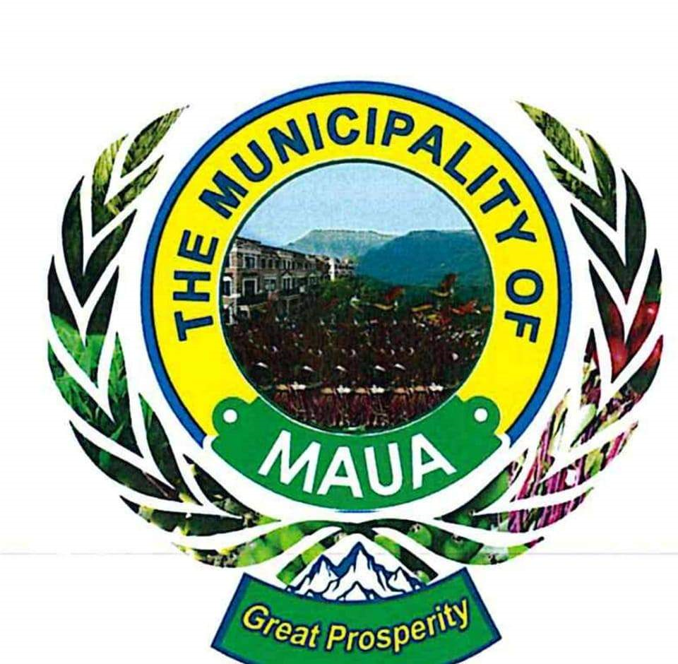

**MAUA MUNICIPALITY**

Tel.202381720 Meru County Headquarters

Email: merucounty@meru.go.ke P.O. Box 60200-120

When replying please quote **MERU**

**MINUTES OF MAUA MUNICIPAL BOARD MEETING HELD ON 25/09/2024 HELD AT THE MUNICIPAL BOARDROOM AT 10.00A.M**

**PRESENT**

1. **James Kirema – Chairman**
2. **Judith Muthoni –Vice chairman**
3. **Margaret Ntongai-Member**
4. **Bonface Mwirigi –Member**
5. **Cathrine Marangu- Member**
6. **Mwenda Timothy - Municipal Manager**
7. **CPA Monica Kathono-CEC Lands.**
8. **Arc Gitije Martin- CO Lands.**

**ABSENT WITH APOLOGY**

1. **Rufus Miriti – Member**

**AGENDA**

1. World Bank
2. Garbage situation/drainage
3. Indiscipline at the Calvary area
4. Idep adoption
5. Solid waste policy and Solid Waste plan tabling and adoption

**MIN1: PRELIMINARY**

The meeting opened with a word of prayer by James Kirema. Opening remarks from members were made by the members.Reading of previous minutes

Minutes were read, confirmed by chairman, seconded by Judith Mwambia

**MIN2: MATTERS ARISING**

* the matter of illegal structures was raised and the municipal manager responded by admitting to enforce
* long term solutions for organized kiosks by the board was suggested(modern kiosks
* stray animals were still a problem and the board emphasized on enforcement
* congestion in town was still hurting businesses. illegal food hawkers have increased
* mr mwirigi called on serious implementation of the board resolution once they are passed
* the board complained over the laxity of some members and requested for a meeting with the staff to discuss work related issues
* the issue of sivap market was still pending and more follow up was called for. members resolved to follow up the matter
* board confidentiality was also reiterated
* some areas where lights were not working were highlighted

**MIN 3: WORLD BANK GRANT**

* The municipal manager briefed the board about the progress of the World Bank grant. Members acknowledge the report and suggested that the board to continue giving input to the program.

**MIN 4: CARBAGE SITUATION & DRAINAGE**

* Members noted that there was issue with the collection of the garbage. The Municipal Manager explained the problem with the fuel and assured the members that the problem was resolved.
* Drainage operation was also called for since the rains were almost coming
* Staff dealing with cleanliness were called out to improve their work
* Members gave an ultimatum of two weeks to clear the drainage channel
* Enforcement of the illegal dumping was emphasized
* The sanitation of the toilet was also raised and it was suggested

**MIN 5: IDEP REPORT**

* The integrated development plan for the Maua Town was tabled to the board and discussed by the members
* Members gave their endorsement of the IDEP report and unanimously adopted the plan

**MIN 6: SOLID WASTE MANAGEMENT POLICY, AND SOLID WASTE PLAN.**

* The draft solid waste management policy was tabled to the board and discussed.
* Members endorsed the policy and unanimously adopted the policy.
* The solid waste plan was also tabled, discussed, **and adopted**.

**MIN 7 A.O.B**

* The board were assured that the tenure for the board was anchored in law
* The board was notified that there was a new member of the board Mr Mutembei and was yet to be gazetted
* A member suggested that we invite Hon JohnPaul – the MP to the board to share on municipality development
* The board set the next special meeting on 16th October 2024

**MIN 8 ADJOURNEMENT**

There being no other business the meeting was closed with a word of prayer by Margaret Ntongai at 1.12p.m

**PREPARED BY……………………………………………………..**

**CONFIRMED BY……………………………………………………**